Data Cleaning & Preprocessing Documentation

Introduction
By creating a single, transparent data preprocessing pipeline, data leakage and temporal bias are prevented and all modeling approaches both neural and non-neural are trained on a uniform basis.
Hyndman and Athanasopoulos (2021) provided best practices for time-series data cleaning and feature preparation, and Wilcox (2012) provided principles for robust outlier treatment.
Chollet (2021) and Goodfellow, Bengio, and Courville (2016) provided preprocessing guidelines unique to neural networks.
This article provides a clear and repeatable explanation of how the raw hourly electricity dataset was preprocessed and cleaned so that each team member may train a different model (LSTM, GRU, TCN, Tree-based, Linear etc) using the same input. The guiding concepts were:
- One canonical dataset for the whole group (no per-model tweaks).
- Complete timeline (keep all hours, 2016–2022) to preserve seasonality.
- Model-agnostic choices (no feature engineering that privileges one model type).
- Transparency about data gaps: we flag missing weather instead of silently dropping/guessing.
Why this is important: time-series models are extremely vulnerable to uneven preprocessing, leakage, and missing timestamps. Keeping your evaluation trustworthy and avoiding apples-to-oranges comparisons are two benefits of establishing a single, consistent pipeline.

Data overview (inputs → output)
Here is data overview –
Raw input: dataset_mansion.csv
- Hourly consumption: 2015-12-31 22:00 → 2022-05-31 20:00
- Hourly weather: 2017-01-01 → 2022-05-31
- Note: Hour t represents consumption between t-1 and t (per assignment).
Cleaned output: dataset_mansion_cleaned.csv
- Continuous hourly index (no gaps) from first to last timestamp found in raw.
- Kept full 2016–2022 period to support all modeling strategies.
- Weather gaps preserved via a flag (weather_missing) so modelers can include/exclude as they wish.

Cleaning decisions (what & why)

- Timestamp normalization & continuity
Electricity consumption data must have a consistent, evenly spaced timeline to preserve temporal relationships essential for forecasting.
- What:
  - Auto-detect the timestamp column (e.g., MTime), parse to datetime, sort, drop invalid rows.
  - Remove duplicate timestamps (keep the first).
  - Resample to hourly with .resample('H').asfreq() to enforce a complete hourly index.
- Why:
  - Neural and non-neural time-series models need a regularly spaced sequence.
  - Duplicates and ragged time grids cause silent leakage or unstable training.
2) Target (consumption) imputation
According to Hyndman and Athanasopoulos (2021), interpolation at short intervals (≤ 6 hours) is a widely used and experimentally validated technique for continuous sensor data.
This strikes a compromise between maintaining temporal continuity and little distorting underlying consumption patterns.
- What:
  - Convert to numeric; interpolate small gaps (≤ 6 hours) using time-based interpolation; then forward-fill/back-fill remaining gaps as a conservative fallback.
  - No deletion of rows to keep the time grid intact.
- Why:
  - Small gaps are common in sensor telemetry; time interpolation is stable for short spans.
  - For longer gaps, ffill/bfill preserves continuity without inventing unreal patterns.

- Weather handling & explicit missingness
Temperature, humidity, wind speed, and other meteorological factors are important indicators of household power demand, especially in regions where consumption patterns are dominated by heating and cooling loads.
However, irregular or missing weather observations might skew model training, therefore these deficiencies need to be addressed in a clear and methodical manner (Hyndman & Athanasopoulos, 2021).

- What:
  - Detect weather columns (temperature, humidity, precip, wind, pressure…).
  - Convert to numeric; same imputation rule as target: interpolate small gaps (≤ 6h), then ffill/bfill.
  - Crucially add weather_missing flag that marks hours where weather was originally absent (especially pre-2017). This is computed from the unresampled raw data aligned to the hourly grid; if a weather column didn’t exist, we conservatively mark pre-2017 as missing.
- Why:
  - Different teammates will use different models. Some may want to drop hours without real weather; others may keep them and let the model learn from the flag.
  - A binary missingness indicator is a standard, transparent approach to exogenous gaps.

4) Outlier treatment (winsorization)
As suggested by Wilcox (2012), winsorization clipping extreme values to the first and 99th percentiles was used to reduce the impact of severe spikes without eliminating data, preserving sequential integrity, which is essential for time-series models (Goodfellow et al., 2016).
- What:
  - Cut consumption to the 1st and 99th percentiles (winsorization).
- Why:
  - Rare spikes/outliers can dominate loss functions and destabilize training—especially for neural nets.
  - Without erasing data, winsorization maintains ordering and lessens excessive impact.
5) Light, model-agnostic time features
In line with feature engineering techniques in applied forecasting literature, seasonality modeling across algorithms is supported by using calendar-based features like hour-of-day and day-of-week (Hyndman & Athanasopoulos, 2021; Chollet, 2021).
- What:
  - Add hour, day-of-week, month, is_weekend, heating_season (Oct–Apr).
  - Provide optional cyclic encodings (hour_sin, hour_cos, doy_sin, doy_cos) widely useful across models.
- Why:
  - Without committing to intricate feature engineering that could skew the comparison, these are general calendar cues that many models benefit from.

Exact processing flow (matches the shared notebook/script)
- Load & inspect
  - Read CSV; detect time column; parse datetimes; drop rows with invalid times; set index; sort.
- Deduplicate & resample
  - Remove duplicate timestamps; resample to hourly (asfreq) to enforce a continuous grid.
- Column detection
  - Detect consumption column (common names or heuristics).
  - Detect weather columns by name patterns.
- Type conversion
  - Cast consumption & weather columns to numeric (errors='coerce').
- Weather missingness flag
  - Align original raw to hourly; for the first found weather column, mark NaN → 1 in weather_missing.
  - If not present, default to 1 before 2017-01-01 (documented).
- Imputation
  - Interpolate small gaps (≤ 6h) using time interpolation.
  - Then ffill/bfill for any remaining NaN.
  - Assert no NaN remains in consumption.
- Winsorize target
  - Clip consumption to [P1, P99] to reduce the influence of extreme spikes.
- Add time features
  - hour, dow, month, is_weekend, heating_season (+ optional cyclic encodings).
- Save
  - Write dataset_mansion_cleaned.csv for shared use.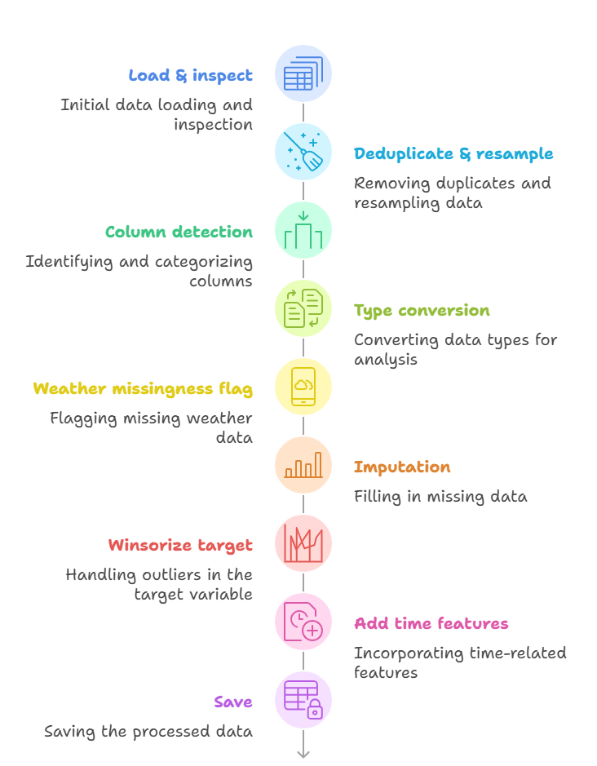

Figure 1: Exact processing flow

Added columns (data dictionary)
Data dictionary columns are –
Column | Type | Description
weather_missing | int {0,1} | 1 if weather was originally missing for that hour; 0 otherwise.
hour | int | Hour of day [0–23].
dow | int | Day of week [0=Mon … 6=Sun].
month | int | Month [1–12].
is_weekend | int {0,1} | 1 if Saturday/Sunday; 0 otherwise.
heating_season | int {0,1} | 1 if month ∈ {Oct–Apr}; else 0.
hour_sin/cos | float | Cyclic encoding of hour (optional).
doy_sin/cos | float | Cyclic encoding of day-of-year (optional).

Table 1: Added columns(Data Dictionary)

How teammates should use the cleaned file
- Everyone loads the same file: dataset_mansion_cleaned.csv.
- If your model uses weather: either
  - filter to weather_missing == 0 (use only hours with real weather), or
  - keep all data and include weather_missing as an input feature.
- Assignment splits (strict, no leakage):
  - Train: 2016-01-01 → 2020-09-30
  - Test: 2020-10-01 → 2021-09-30
  - Eval A: 2021-10-01 → 2021-12-31
  - Eval B: 2022-01-01 → 2022-02-28
  - Eval C: 2022-03-01 → 2022-05-31
- Scaling/normalization: Fit scalers only on the Train split, then apply to Test/Eval (to prevent look-ahead leakage).
- Baselines first: Evaluate persistence/seasonal-naive to confirm the cleaned data behaves sensibly.

Rationale behind key choices (short justifications)
Every preprocessing choice, including controlled outlier capping, constrained interpolation, and regular hourly resampling, was made with the goal of maximizing model stability and minimizing information leakage (Goodfellow et al., 2016; Hyndman & Athanasopoulos, 2021).

- Keep 2016–2022 (don’t trim):
Maintains extended seasonal cycles and permits fair cross-model comparisons. Weather absence is marked rather than concealed.
- Interpolate ≤ 6 hours, then ffill/bfill:
Small gaps likely reflect short sensor outages; linear time interpolation is standard. Longer gaps are rare; ffill/bfill is conservative and avoids inventing structure.
- Winsorize instead of deleting:
Deletes break the time grid. Clipping reduces undue influence while keeping continuity (important for sequence learners).
- Light calendar features only:
Advantageous for all model classes and prevents the dataset from being skewed toward any architecture.

Reproducibility & versioning
- Paths & parameters (e.g., interpolation limit, quantiles) are defined at the top of the notebook for transparency.
- If any teammate changes cleaning parameters, save as a separate version (e.g., dataset_mansion_cleaned_v2.csv) to avoid silent drift.

Limitations & notes
- Weather before 2017 is unknown; the flag exposes this uncertainty. Modelers should decide how to handle it.
- Winsorization level (P1–P99) is a trade-off. If a model is sensitive to clipping, consider re-training with P0.5–P99.5 or no clipping and report differences.
- No holiday calendar was added (optional future feature).

Reference
Chollet, F. (2021). Deep Learning with Python (2nd ed.). Manning. https://sourestdeeds.github.io/pdf/Deep%20Learning%20with%20Python.pdf
Goodfellow, I., Bengio, Y., & Courville, A. (2016). Deep Learning. MIT Press. https://mitpress.mit.edu/9780262035613/deep-learning/
Hyndman, R. J., & Athanasopoulos, G. (2021). Forecasting: Principles and Practice (3rd ed.). OText. https://otexts.com/fpp3/
Wilcox, R. R. (2012). Introduction to Robust Estimation and Hypothesis Testing (3rd ed.). Academic Press. https://www.sciencedirect.com/book/9780123869838/introduction-to-robust-estimation-and-hypothesis-testing

